Lepidoptera
Erebidae Family

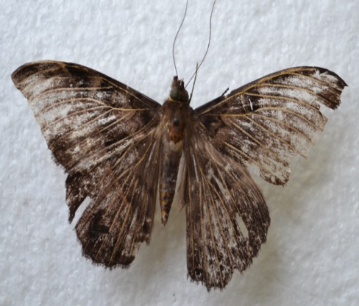
1) Locality: BMNP
Woreda: Delo-Mena
Kebele: Wabero
Altitude: 1321m
Habitat: Agriculture
Sc. Name: Cyligramma latona

Key morphological characters

Key habitat features
It is open agricultural land under cultivation of Sesamum indicum and Eragrostis tef. Tree species such as Acacia albida (most dominant), Croton macrostachyus (second most dominant), Combretum molle, Combretum collinum and Terminalia schimperi were found scattered in the Sesamum indicum farmland. Herbs such as Geranium favosum and Kosteletzkya begoniifolia grow as weed in the farmland.
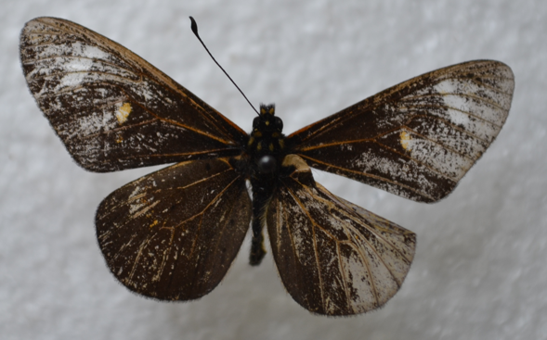
Nymphalidae Family
2) Locality: BMNP
Woreda: Delo-Mena
Kebele: Wabero
Altitude: 1520m
Habitat: Buffer
Sc. Name: Actinote spp.

Key morphological characters

Key habitat features
It is moist afromontane forest with moderate disturbance. Tree species such as Ocotea kenyensis (most abundant), Podocarpus falcatus (second most abundant), Celtis africana, , Syzygium guineense, Filicium decipiens and Croton macrostachyus form relatively thick canopy of the area. Achyrospermum schimperi, Desmodium repandum and Crotalaria sp form thick ground herbaceous cover.
3) Locality: BMNP
Woreda: Delo-Mena
Kebele: Wabero
Altitude: 1580m
Habitat: Core
Sc. Name: Amauris albimaculata

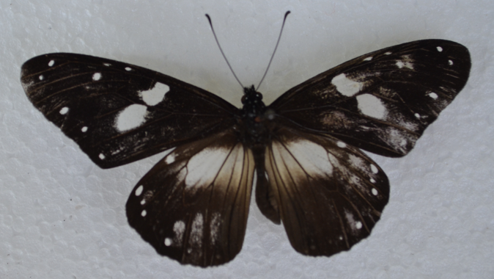

Key morphological characters

Key habitat features
It is moist afromontane forest with little disturbance. Tree species such as Ocotea kenyensis, Syzygium guineense (most abundant), Croton macrostachyus (second most abundant), Ficus sur, Commiphora habessinica, Podocarpus falcatus and Coffea arabica form relatively thick canopy of the area. Pavonia urens Nicandra physaloides and Crotalaria sp form thick ground herbaceous cover.

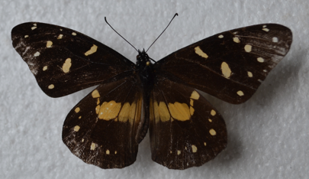
4)Locality: BMNP
Woreda: Delo-Mena
Kebele: Wabero
Altitude: 1570m
Habitat: Core
Sc. Name: Amauris echeria

Key morphological characters

Key habitat features
It is moist afromontane forest with little disturbance. Tree species such as Pouteria adolfi-friederici (most abundant), Syzygium guineense(second most abundant), Ocotea kenyensis Celtis africna, Podocarpus falcatus and Coffea arabica form relatively thick canopy of the area. Ageratum conyzoides, Pavonia urens and Crotalaria sp form thick ground herbaceous cover.
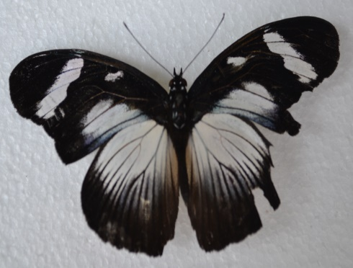
5) Locality: BMNP
Woreda: Delo-Mena
Kebele: Wabero
Altitude: 1535m
Habitat: Buffer
Sc. Name: Amauris niavius

Key morphological characters

Key habitat features
It is moist afromontane forest with moderate disturbance. The area exhibit diverse tree species such as Pouteria adolfi-friederici (most abundant), Syzygium guineense (second most abundant), Ocotea kenyensis Celtis africna, Podocarpus falcatus, Syzgium cumini, Fagaropsis angolensis, Ehretia cymosa, Commiphora habessinica, Croton macrostachyus, Maytanus ovatus, Saxifraga hederifolia, Diospyros abyssinica and Coffea arabica form relatively thick canopy of the area. Crotalaria sp predominately form thick ground herbaceous cover.

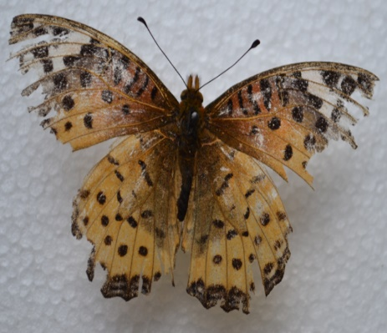
6) Locality: BMNP
Woreda: Dinsho
Kebele:
Altitude: 3048m
Habitat: Core
Sc. Name: Argynnis hyperbius

Key morphological characters

Key habitat features
It is montane grassland with little disturbance from livestock, but other wildlife species such as mountain nyala, bohr reedbuck, warthog fairly abundant and freely graze in the area. There are not tree species. Cineraria abyssinica predominately form thick ground herbaceous cover.
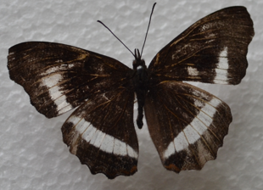
7) Locality: BMNP
Woreda: Delo-Mena
Kebele: Wabero
Altitude: 1513m
Habitat: Buffer
Sc. Name: Athyma selenophora

Key morphological characters

Key habitat features
It is moist afromontane forest with moderate disturbance. The area exhibit diverse tree species such as Syzygium guineense (second most abundant), Ocotea kenyensis, Podocarpus falcatus, Commiphora habessinica, Croton macrostachyus, Ficus sur and Coffea arabica form relatively thick canopy of the area. Hypoestes forskaolii, Desmodium repandum and Crotalaria sp form thick ground herbaceous cover.

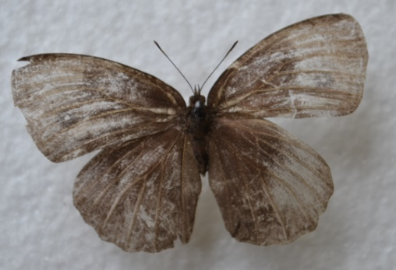

8) Locality: BMNP
Woreda: Delo-Mena
Kebele: Wabero
Altitude: 1391m
Habitat: Agriculture
Sc. Name: Bicyclus funebris

Key morphological characters

Key habitat features
It is open agricultural land under cultivation of Sesamum indicum and Mangifera indica. Tree species such as Terminalia schimperi and Ficus vasta (most dominant), Croton macrostachyus, Combretum collinum, Ficus sycomorus and Annona senegalenis were found scattered in the Sesamum indicum farmland. Herbs such as Isoglossa somalensis, Geranium favosum, Cyanotis barbata and Commelina benghalensis grow as weed in the farmland.

12 agri, 13 buffer, 66 buffer, 39 core, 57 core,

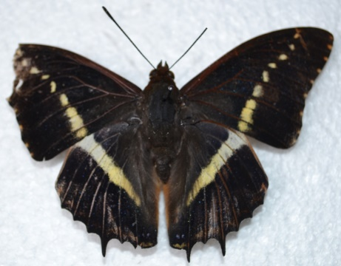
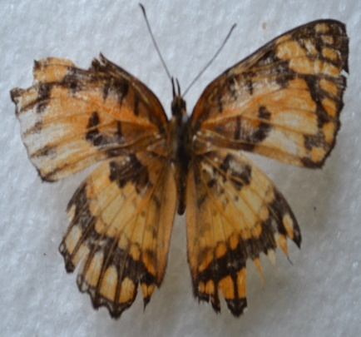
10) Locality: BMNP
Woreda: Delo-Mena
Kebele: Wabero
Altitude: 1557m
Habitat: Buffer
Sc. Name: Charaxes brutus

9) Locality: BMNP
Woreda: Delo-Mena
Kebele: Wabero
Altitude: 1377m
Habitat: Agriculture
Sc. Name: Byblia spp.

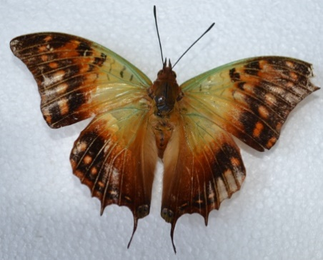

13) Locality: BMNP
Woreda: Delo-Mena
Kebele: Wabero
Altitude: 1524m
Habitat: Buffer
Sc. Name: Charaxes varanes

12) Locality: BMNP
Woreda: Delo-Mena
Kebele: Wabero
Altitude: 1319m
Habitat: Agriculture
Sc. Name: Charaxes castor
11) Locality: BMNP
Woreda: Delo-Mena
Kebele: Wabero
Altitude: 1271m
Habitat: Buffer
Sc. Name: Charaxes candiope

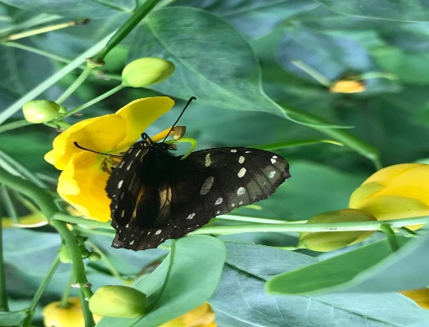
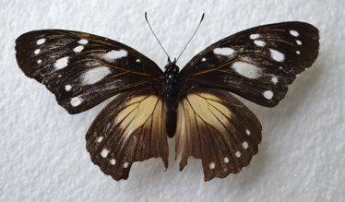
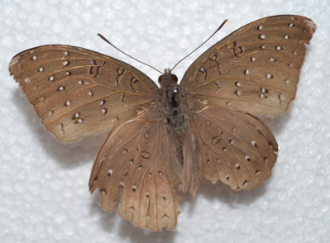
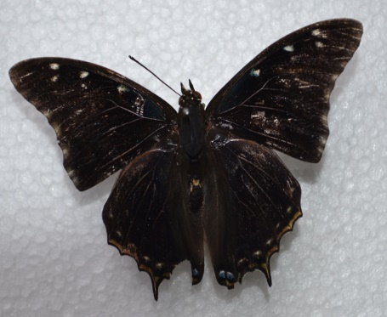

16) Locality: BMNP
Woreda: Delo-Mena
Kebele: Wabero
Altitude: 1433m
Habitat: Buffer
Sc. Name: Hypolimnas anthedon

15) Locality: BMNP
Woreda: Delo-Mena
Kebele: Wabero
Altitude: 1580m
Habitat: Core
Sc. Name: Hamanumida daedalus

14) Locality: BMNP
Woreda: Delo-Mena
Kebele: Wabero
Altitude: 1271m
Habitat: Buffer
Sc. Name: Eriboea galawadiwosi

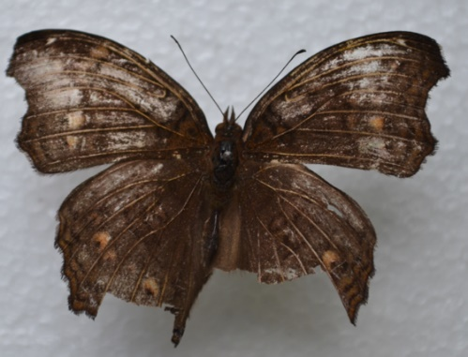
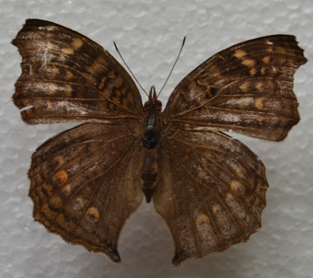
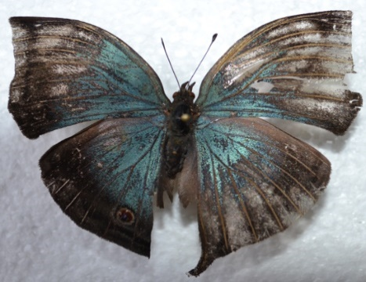

19) Locality: BMNP
Woreda: Delo-Mena
Kebele: Wabero
Altitude: 1431m
Habitat:Agriculture
Sc. Name: Junonia iphita

18) Locality: BMNP
Woreda: Delo-Mena
Kebele: Wabero
Altitude: 1405m
Habitat: Agriculture
Sc. Name: Junonia hedonia

17) Locality: BMNP
Woreda: Delo-Mena
Kebele: Wabero
Altitude: 1520m
Habitat: Buffer
Sc. Name: Junonia ansorgei

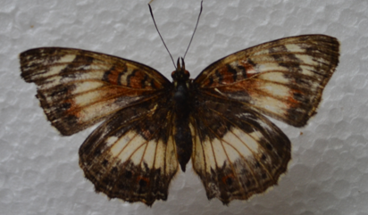
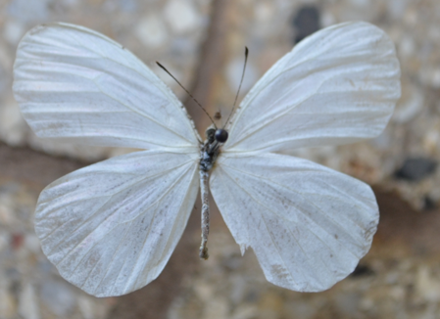
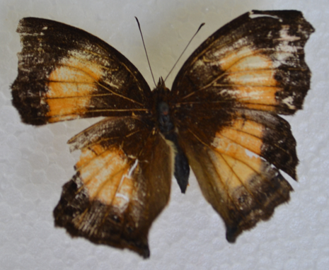

22) Locality: BMNP
Woreda: Delo-Mena
Kebele: Wabero
Altitude: 1416m
Habitat: Agriculture
Sc. Name: Leptosia alcesta

21) Locality: BMNP
Woreda: Delo-Mena
Kebele: Wabero
Altitude: 1572m
Habitat: Core
Sc. Name: Junonia terea

20) Locality: BMNP
Woreda: Delo-Mena
Kebele: Wabero
Altitude: 1590m
Habitat: Core
Sc. Name: Junonia sophia

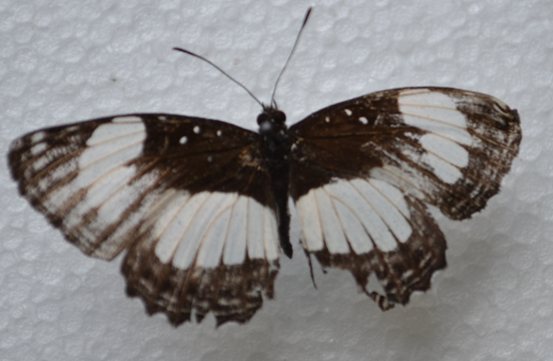
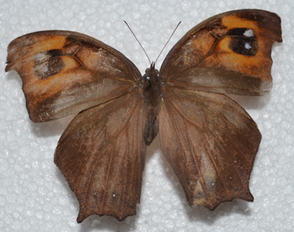
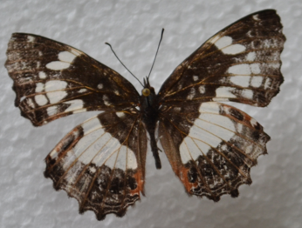

25) Locality: BMNP
Woreda: Delo-Mena
Kebele: Wabero
Altitude: 1339m
Habitat: Agriculture
Sc. Name: Neptis laeta

24) Locality: BMNP
Woreda: Delo-Mena
Kebele: Wabero
Altitude: 1271m
Habitat: Buffer
Sc. Name: Neptidopsis ophione

23) Locality: BMNP
Woreda: Delo-Mena
Kebele: Wabero
Altitude: 1405m
Habitat: Agriculture
Sc. Name: Melanitis leda

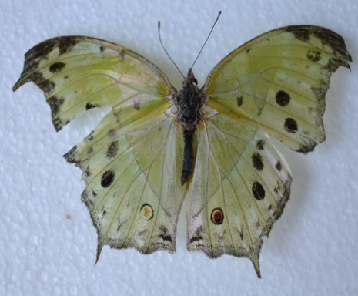
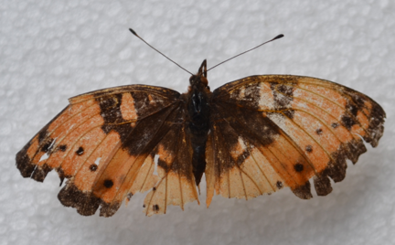
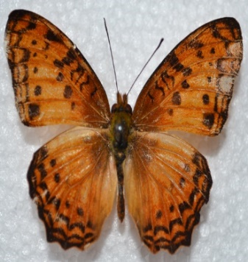

28) Locality: BMNP
Woreda: Delo-Mena
Kebele: Wabero
Altitude: 1570m
Habitat: Core
Sc. Name: Protogoniomorpha anacardii

27) Locality: BMNP
Woreda: Goba
Kebele:
Altitude: 3830
Habitat: Core
Sc. Name: Precis archesia
26) Locality: BMNP
Woreda: Delo-Mena
Kebele: Wabero
Altitude: 1535m
Habitat: Buffer
Sc. Name: Phalanta eurytis

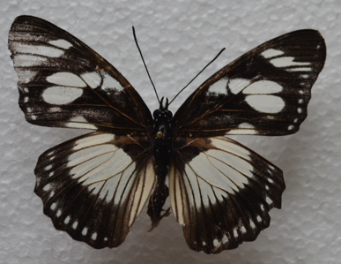
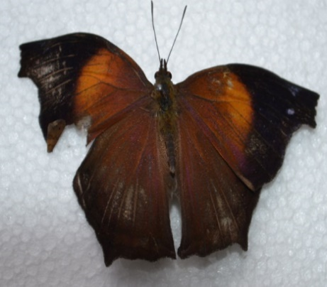
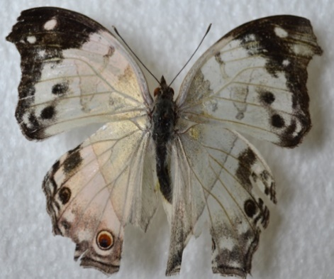

29) Locality: BMNP
Woreda: Delo-Mena
Kebele: Wabero
Altitude: 1580m
Habitat: Core
Sc. Name: Protogoniomorpha parhassus

31) Locality: BMNP
Woreda: Delo-Mena
Kebele: Wabero
Altitude: 1429m
Habitat: Agriculture
Sc. Name: Salamis cacta

30) Locality: BMNP
Woreda: Delo-Mena
Kebele: Wabero
Altitude: 1513m
Habitat: Buffer
Sc. Name: Pseudacraea lucretia

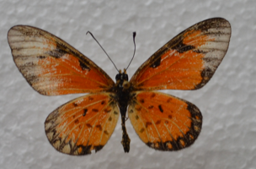
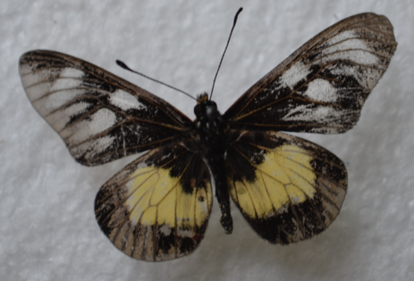
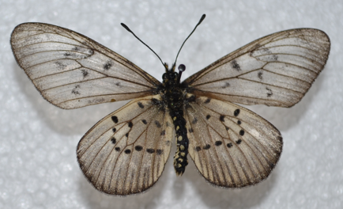

34) Locality: BMNP
Woreda: Delo-Mena
Kebele: Wabero
Altitude: 1336m
Habitat: Agriculture
Sc. Name: Telchinia serena

33) Locality: BMNP
Woreda: Delo-Mena
Kebele: Wabero
Altitude: 1416m
Habitat: Agriculture
Sc. Name: Telchinia parrhasia

32) Locality: BMNP
Woreda: Dinsho
Kebele:
Altitude: 3048m
Habitat: Core
Sc. Name: Telchinia necoda

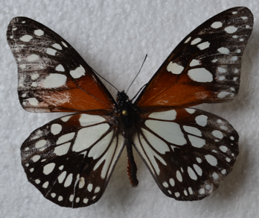
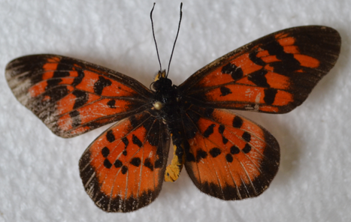
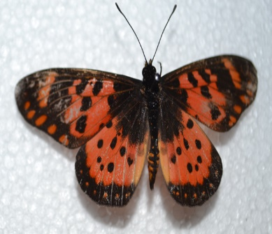

37) Locality: BMNP
Woreda: Delo-Mena
Kebele: Wabero
Altitude: 1513m
Habitat: Buffer
Sc. Name: Tirumala formosa

36) Locality: BMNP
Woreda: Delo-Mena
Kebele: Wabero
Altitude: 1520m
Habitat: Buffer
Sc. Name: Tildia spp.

35) Locality: BMNP
Woreda: Delo-Mena
Kebele: Wabero
Altitude: 1557m
Habitat: Buffer
Sc. Name: Tildia acara

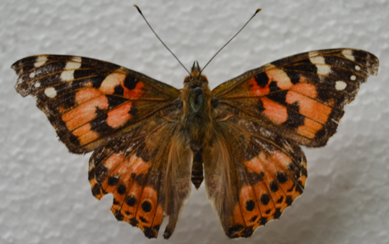
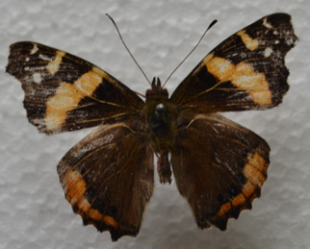
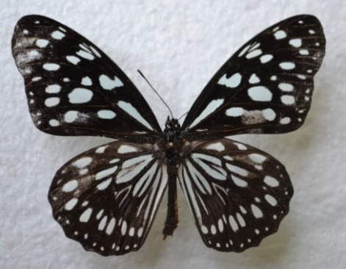

38) Locality: BMNP
Woreda: Delo-Mena
Kebele: Wabero
Altitude: 1336m
Habitat: Agriculture
Sc. Name: Tirumala petiverana

40) Locality: BMNP
Woreda: Delo-Mena
Kebele: Wabero
Altitude: 1429m
Habitat: Agriculture
Sc. Name: Vanessa cardui

39) Locality: BMNP
Woreda: Delo-Mena
Kebele: Goba
Altitude: 3838m
Habitat: Core
Sc. Name: Vanessa abyssinica

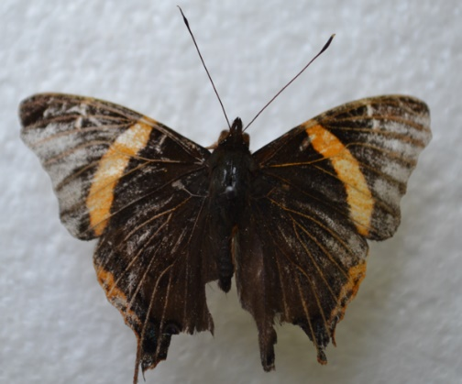

41) Locality: BMNP
Woreda: Delo-Mena
Kebele: Wabero
Altitude: 1416m
Habitat: Agriculture
Sc. Name: Vanessa dimorphica

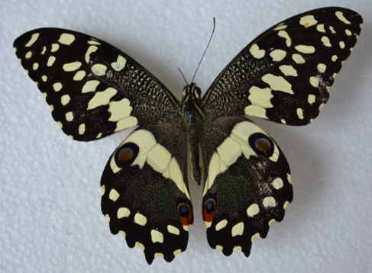
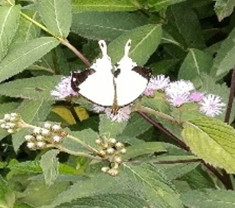
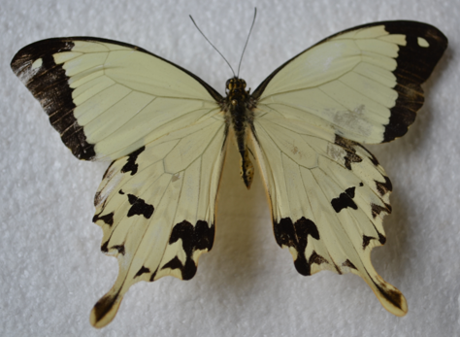
Papilionidae Family

43) Locality: BMNP
Woreda: Delo-Mena
Kebele: Wabero
Altitude: 1580m
Habitat: Core
Sc. Name: Papilio demodocus

42) Locality: BMNP
Woreda: Delo-Mena
Kebele: Wabero
Altitude: 1271m
Habitat: Buffer
Sc. Name: Papilio dardanus

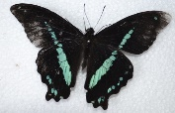
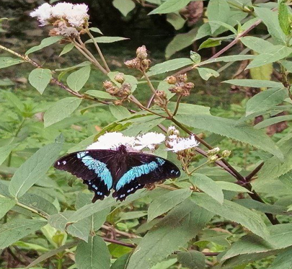
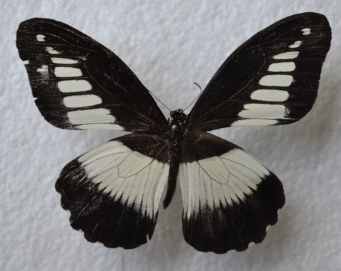

44) Locality: BMNP
Woreda: Delo-Mena
Kebele: Wabero
Altitude: 1590m
Habitat: Core
Sc. Name: Papilio echerioides

45) Locality: BMNP
Woreda: Delo-Mena
Kebele: Wabero
Altitude: 1590m
Habitat: Core
Sc. Name: Papilio nireus

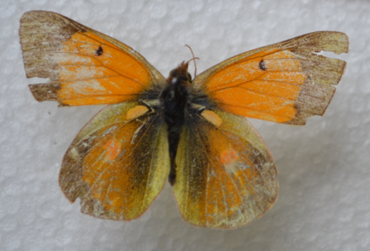
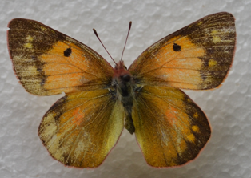
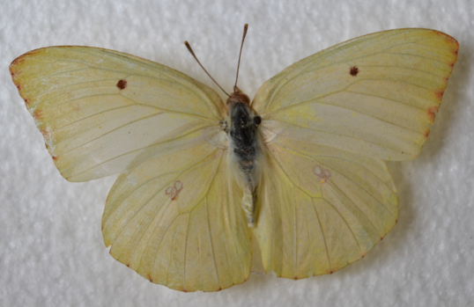
Pieridae Family

46) Locality: BMNP
Woreda: Delo-Mena
Kebele: Wabero
Altitude: 1271m
Habitat: Buffer
Sc. Name: Catopsilia florella

48) Locality: BMNP
Woreda: Goba
Kebele:
Altitude: 3830m
Habitat: Core
Sc. Name: Colias electo

47) Locality: BMNP
Woreda: Goba
Kebele:
Altitude: 3847m
Habitat: Core
Sc. Name: Colias croceus

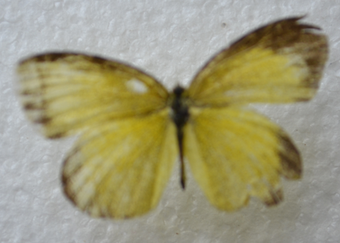
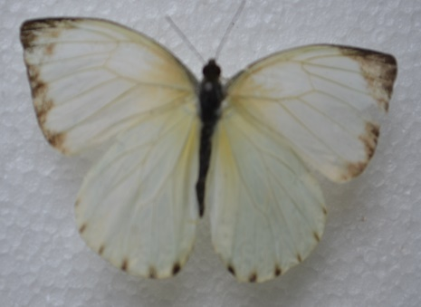
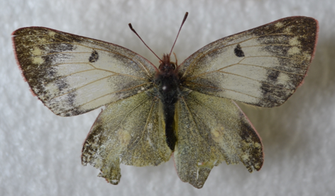

51) Locality: BMNP
Woreda: Dinsho
Kebele:
Altitude: 3056m
Habitat: Core
Sc. Name: Eurema brigitta

50) Locality: BMNP
Woreda: Delo-Mena
Kebele: Wabero
Altitude: 1590m
Habitat: Core
Sc. Name: Dixeia pigea

49) Locality: BMNP
Woreda: Delo-Mena
Kebele:
Altitude: 3830m
Habitat: Core
Sc. Name: Colias phicomone

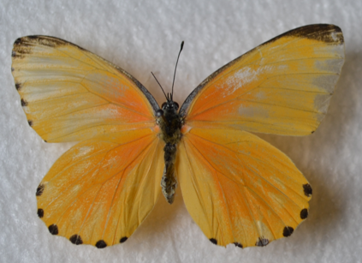
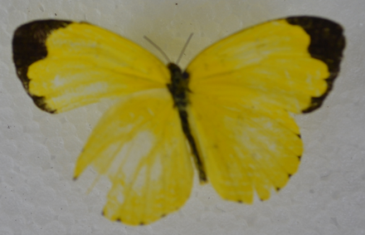
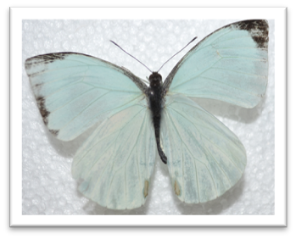

54) Locality: BMNP
Woreda: Delo-Mena
Kebele: Wabero
Altitude: 1557m
Habitat: Buffer
Sc. Name: Nepheronia thalassina

53) Locality: BMNP
Woreda: Delo-Mena
Kebele: Wabero
Altitude: 1382m
Habitat: Agriculture
Sc. Name: Mylothris agathina

52) Locality: BMNP
Woreda: Delo-Mena
Kebele: Wabero
Altitude: 1420m
Habitat: Buffer
Sc. Name: Eurema desjardinsii

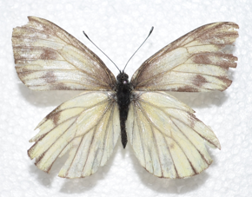
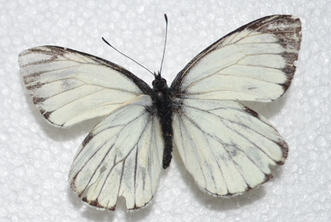

57) Locality: BMNP
Woreda: Dinsho
Kebele:
Altitude: 3053m
Habitat: Core
Sc. Name: Pieris napi
56) Locality: BMNP
Woreda: Goba
Kebele:
Altitude: 3830
Habitat: Core
Sc. Name: Pieris marginalis

55) Locality: BMNP
Woreda: Dinsho
Kebele:
Altitude: 3068m
Habitat: Core
Sc. Name: Pieris brassicoides

Sphingidae Family
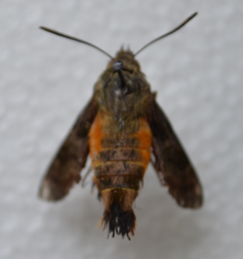

58) Locality: BMNP
Woreda: Goba
Kebele:
Altitude: 3854m
Habitat: Core
Sc. Name: Macroglossum trochilus

Key morphological features
Order: Coleoptera
Scarabaeidae Family
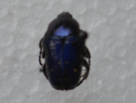

59) Locality: BMNP
Woreda: Delo-Mena
Kebele: Wabero
Altitude: 1557m
Habitat: Buffer
Sc. Name: Leucocelis spp

Key morphological features
- Lamellate antennae
- Spiny legs with five-segmented tarsi
Key Habitat Characteristics

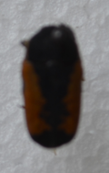

60) Locality: BMNP
Woreda: Delo-Mena
Kebele: Wabero
Altitude: 1336m
Habitat: Agriculture
Sc. Name: Pachnoda spp

Key morphological features
- Quadrate head with small eyes and reduced, lamellate antennae
- The ventral side of the body is vivid and conspicuous hue of metallic red
Key Habitat Characteristics

Order: Diptera
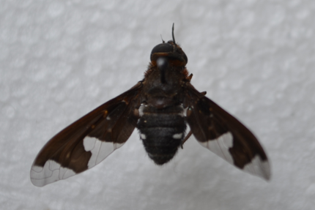
Bombyliidae Family

61) Locality: BMNP
Woreda: Delo-Mena
Kebele: Wabero
Altitude: 1391m
Habitat: Agriculture
Sc. Name: Exoprosopa spp

Key morphological features
- The head is large and only loosely attached to the thorax
- The antenna are small and well separated.
Key Habitat Characteristics
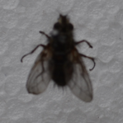
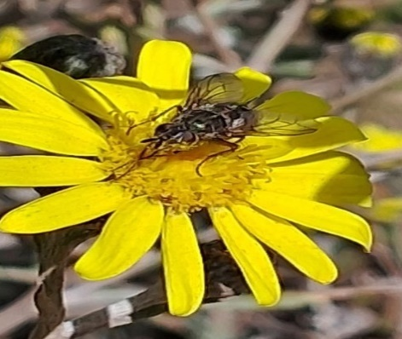
Muscidae Family

62) Locality: BMNP
Woreda: Goba
Kebele:
Altitude: 4055m
Habitat: Core
Sc. Name: Musca domestica

Key morphological features
- Have two wings, with the fourth longitudinal wing vein featuring a sharp upward turn, a key identifying characteristic
- The head is dominated by sponging mouthparts and large, red/brown compound eyes surrounded by a light gold stripe
Key Habitat Characteristics

Syrphidae Family
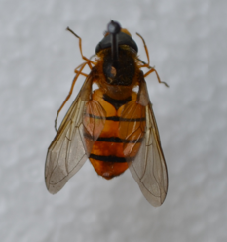
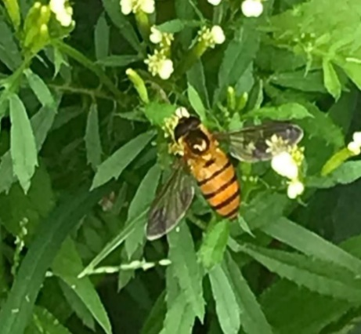

63) Locality: BMNP
Woreda: Delo-Mena
Kebele: Wabero
Altitude: 1271m
Habitat: Buffer
Sc. Name: Phytomia spp.

Key morphological features
- Adults are robust to slender flies 1/8 to 1 inch (4–25 mm) long, varying by species.
- The broad head is about the width of the abdomen or wider and has large eyes with distinct antennae
Key Habitat Characteristics

Order: Hymenoptera
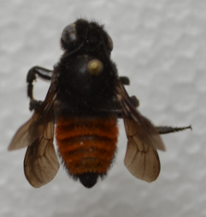
Andrenidae Family

64) Locality: BMNP
Woreda: Delo-Mena
Kebele: Wabero
Altitude: 1513m
Habitat: Buffer
Sc. Name: Andrena spp.

Key morphological features
- Short-tongued bees with two subantennal sutures, a pointed glossa and straight basal vein in the forewing
- Head, mesosoma and metasoma clothed with long hairs
Key Habitat Characteristics

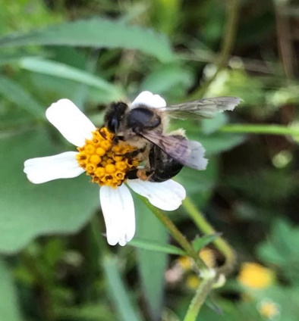
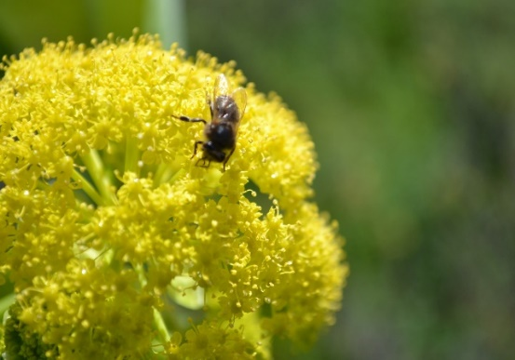
Apidae Family

65) Locality: BMNP
Woreda: Dinsho
Kebele:
Altitude: 3048m
Habitat: Core
Sc. Name: Apis mellifera

Key morphological features
- Long antennal flagellum; pale yellow stripes adjacent to the eye
- Marginal cell of forewing long, about four times as long as distance between marginal cell and distal end of forewing.
Key Habitat Characteristics

66) Locality: BMNP
Woreda: Delo-Mena
Kebele: Wabero
Altitude: 1532m
Habitat: Buffer
Sc. Name: Xylocopa caffra
Key morphological features
- The females are black with two white or yellow bands over the hind thorax and first abdominal segment respectively,
- Males are uniform greenish yellow in colour
Key Habitat Characteristics

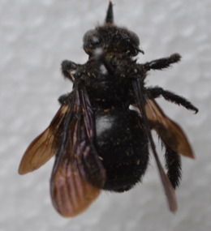
67) Locality: BMNP
Woreda: Delo-Mena
Kebele: Wabero
Altitude: 1590m
Habitat: Core
Sc. Name: Xylocopa combusta

Key morphological features
- Black body with black hair on the head and the thorax
- Bristles on the pygidial area are reddish
Key Habitat Characteristics

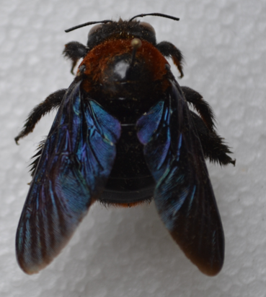

68) Locality: BMNP
Woreda: Delo-Mena
Kebele: Wabero
Altitude: 1420m
Habitat: Buffer
Sc. Name: Xylocopa flavorufa

Key morphological features
- Large size, with females reaching lengths of up to 2.5 cm (1 in), mostly black, with reddish yellow color on the thorax
- Males possess hollows on their hind legs, while females have pollen baskets
Key Habitat Characteristics

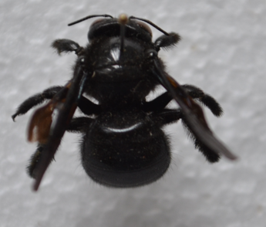
69) Locality: BMNP
Woreda: Delo-Mena
Kebele: Wabero
Altitude: 1535m
Habitat: Buffer
Sc. Name: Xylocopa gaullei

Key morphological features
- Black narrowed wrist
- The ivory markings on the face extend very high above the antennal sockets
Key Habitat Characteristics

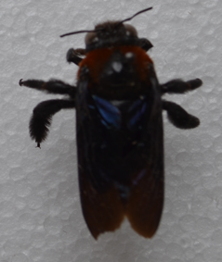
70) Locality: BMNP
Woreda: Delo-Mena
Kebele: Wabero
Altitude: 1590m
Habitat: Core
Sc. Name: Xylocopa hottentotta

Key morphological features
- Integument black, Scutum covered with black or intermixed with whitish hairs dorsa
- Frontal carina from median ocellus towards frons elevated as a keel.
Key Habitat Characteristics

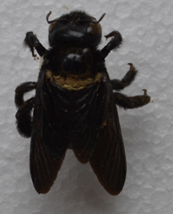
71) Locality: BMNP
Woreda: Delo-Mena
Kebele: Wabero
Altitude: 1433m
Habitat: Buffer
Sc. Name: Xylocopa inconstans

Key morphological features
- Total body length of 26 mm and forewing length 21–23 mm
- The back side of the mesosoma and the first tergite show a white pubescence
Key Habitat Characteristics
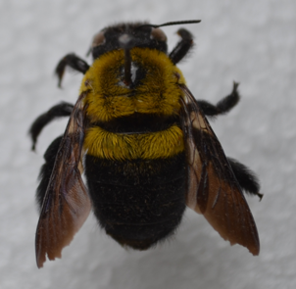
72) Locality: BMNP
Woreda: Delo-Mena
Kebele: Wabero
Altitude: 1377m
Habitat: Agriculture
Sc. Name: Xylocopa olivacea

Key morphological features
- It has a completely yellow thorax and a yellow band on the first tergite
- Abdomen and legs black
Key Habitat Characteristics

Megachilidae Family
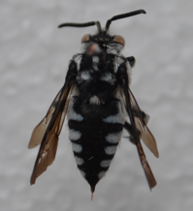
73) Locality: BMNP
Woreda: Delo-Mena
Kebele: Wabero
Altitude: 1535m
Habitat: Buffer
Sc. Name: Coelioxys spp

Key morphological features
- Black to dark brown bees that range in body length from 5–22 mm
- Abdomen of female narrow apically, usually pointed ; scopa absent; axillae with long spine. In males, posterior margin of with distinct long spines of six to nine spines
Key Habitat Characteristics

KBR

Lepidoptera

Erebidae Family
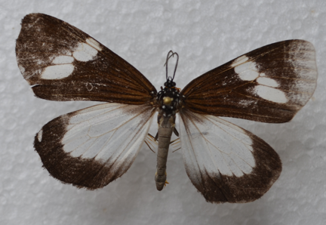

Locality: KBR
Woreda: Gimbo
Kebele: Tula
Altitude: 1812m
Habitat: Agriculture
Sc. Name: Chiromachla leuconoe

Nymphalidae Family
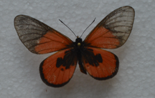
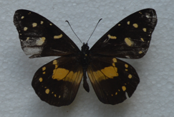
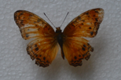

Locality: KBR
Woreda: Gimbo
Kebele: Tula
Altitude: 1690m
Habitat: Agriculture
Sc. Name: Phalanta eurytis

Locality: KBR
Woreda: Gawata
Kebele: Emicho
Altitude: 2143m
Habitat: Core
Sc. Name: Amauris echeria

Locality: KBR
Woreda: Gawata
Kebele: Dema
Altitude: 1697m
Habitat: Buffer
Sc. Name: Acraea insignis

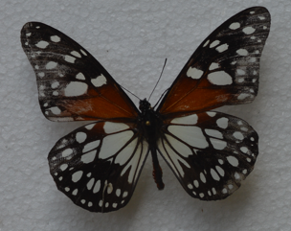
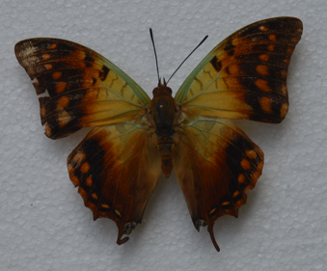
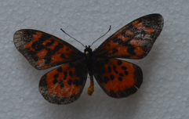

Locality: KBR
Woreda: Gimbo
Kebele: Tula
Altitude: 1724m
Habitat: Agriculture
Sc. Name: Tildia spp.

Locality: KBR
Woreda: Gawata
Kebele: Emicho
Altitude: 2143m
Habitat: Core
Sc. Name: Charaxes candiope

Locality: KBR
Woreda: Gawata
Kebele: Emicho
Altitude: 2143m
Habitat: Core
Sc. Name: Tirumala formosa

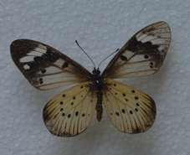
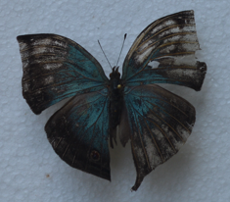
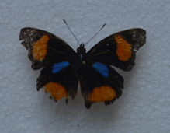

Locality: KBR
Woreda: Gawata
Kebele: Dema
Altitude: 1743m
Habitat: Buffer
Sc. Name: Acraea encedon

Locality: KBR
Woreda: Gimbo
Kebele: Tula
Altitude: 1800m
Habitat: Agriculture
Sc. Name: Junonia ansorgei

Locality: KBR
Woreda: Gawata
Kebele: Dema
Altitude: 1756m
Habitat: Buffer
Sc. Name: Junonia westermanni

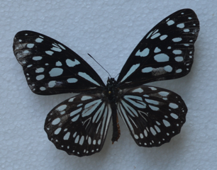
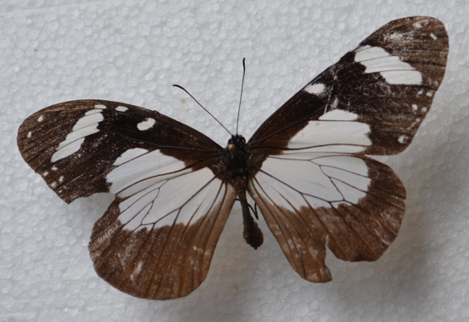
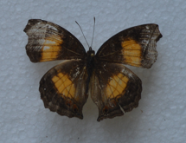

Locality: KBR
Woreda: Gawata
Kebele: Dema
Altitude: 1810m
Habitat: Buffer
Sc. Name: Junonia terea

Locality: KBR
Woreda: Gawata
Kebele: Emicho
Altitude: 2010m
Habitat: Core
Sc. Name: Amauris niavius

Locality: KBR
Woreda: Gawata
Kebele: Emicho
Altitude: 2010m
Habitat: Core
Sc. Name: Tirumala petiverana

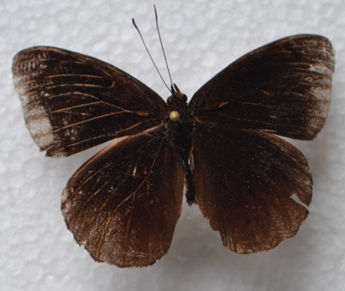
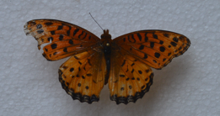

Locality: KBR
Woreda: Gawata
Kebele: Dema
Altitude: 1756m
Habitat: Buffer
Sc. Name: Bicyclus spp.

Locality: KBR
Woreda: Gimbo
Kebele: Tula
Altitude: 1812m
Habitat: Agriculture
Sc. Name: Argynnis hyperbius

Locality: KBR
Woreda: Gawata
Kebele: Dema
Altitude: 1724m
Habitat: Buffer
Sc. Name: Precis archesia

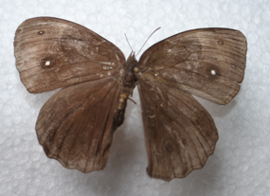
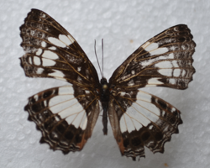
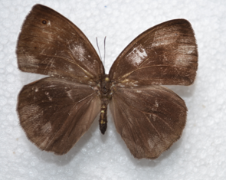

Locality: KBR
Woreda: Gawata
Kebele: Emicho
Altitude: 2010m
Habitat: Core
Sc. Name: Neptis laeta

Locality: KBR
Woreda: Gawata
Kebele: Dema
Altitude: 1764m
Habitat: Buffer
Sc. Name: Bicyclus ena

.

Locality: KBR
Woreda: Gawata
Kebele: Dema
Altitude: 1810m
Habitat: Buffer
Sc. Name: Bicyclus funebris

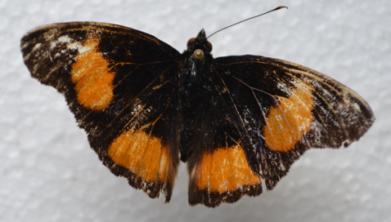
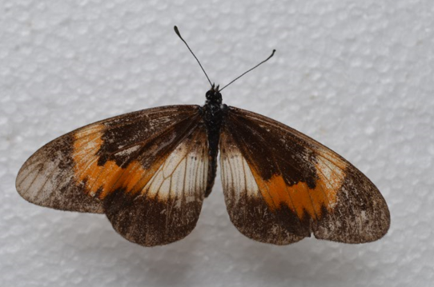
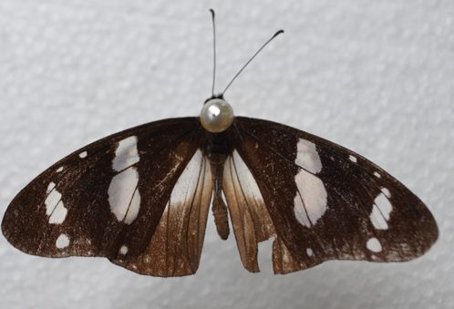

Locality: KBR
Woreda: Gimbo
Kebele: Tula
Altitude: 1757m
Habitat: Agriculture
Sc. Name: Junonia hierta

Locality: KBR
Woreda: Gawata
Kebele: Emicho
Altitude: 1902m
Habitat: Core
Sc. Name: Telchinia jodutta

Locality: KBR
Woreda: Gawata
Kebele: Dema
Altitude: 1800m
Habitat: Buffer
Sc. Name: Amauris ochlea

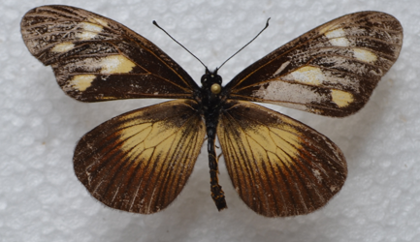
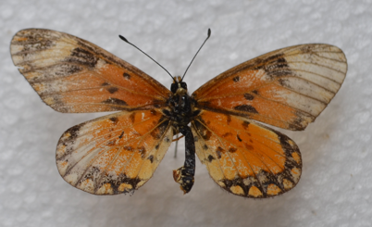
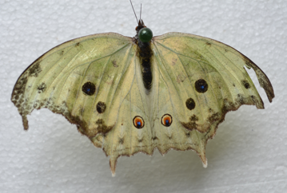

Locality: KBR
Woreda: Gimbo
Kebele: Tula
Altitude: 1739m
Habitat: Agriculture
Sc. Name: Telchinia lycoa

Locality: KBR
Woreda: Gimbo
Kebele: Tula
Altitude: 1833m
Habitat: Agriculture
Sc. Name: Telchinia serena

Locality: KBR
Woreda: Gimbo
Kebele: Tula
Altitude: 1676m
Habitat: Agriculture
Sc. Name: Protogoniomorpha anacardii

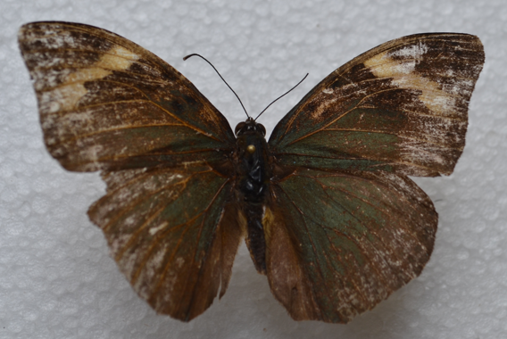
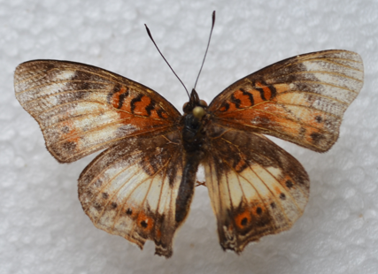
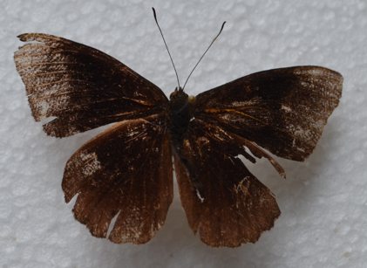

Locality: KBR
Woreda: Gimbo
Kebele: Tula
Altitude: 1833m
Habitat: Agriculture
Sc. Name: Euphaedra spp.

Locality: KBR
Woreda: Gimbo
Kebele: Tula
Altitude: 1812m
Habitat: Agriculture
Sc. Name: Junonia sophia

Locality: KBR
Woreda: Gawata
Kebele: Emicho
Altitude: 2129m
Habitat: Core
Sc. Name: Bicyclus spp.

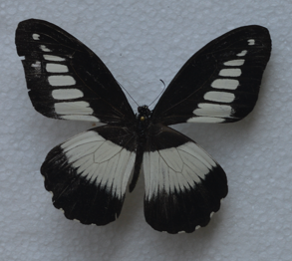
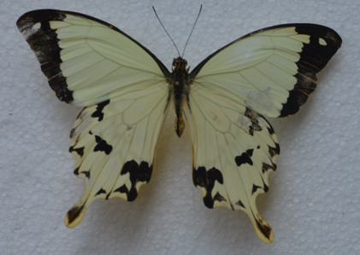
Papilionidae Family
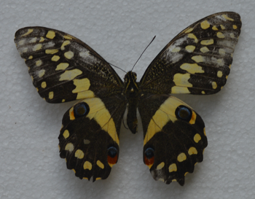

Locality: KBR
Woreda: Gawata
Kebele: Emicho
Altitude: 1962m
Habitat: Core
Sc. Name: Papilio dardanus

Locality: KBR
Woreda: Gawata
Kebele: Emicho
Altitude: 2152m
Habitat: Core
Sc. Name: Papilio demodocus

Locality: KBR
Woreda: Gawata
Kebele: Emicho
Altitude: 2010m
Habitat: Core
Sc. Name: Papilio echerioides

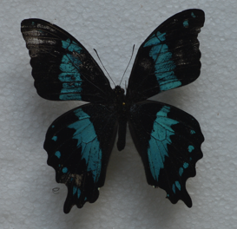

Locality: KBR
Woreda: Gawata
Kebele: Emicho
Altitude: 2129m
Habitat: Core
Sc. Name: Papilio nireus

Pieridae Family
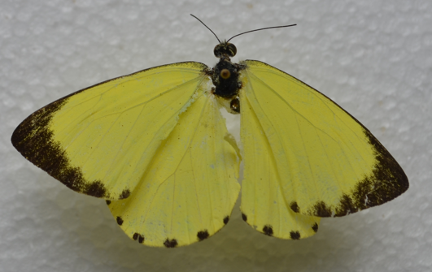
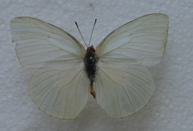
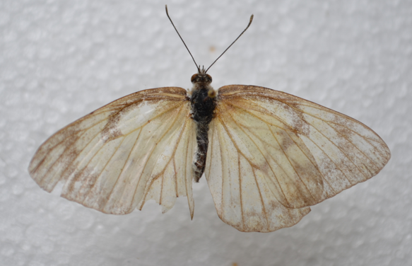

Locality: KBR
Woreda: Gimbo
Kebele: Tula
Altitude: 1724m
Habitat: Agriculture
Sc. Name: Eurema hecabe

Locality: KBR
Woreda: Gawata
Kebele: Dema
Altitude: 1800m
Habitat: Buffer
Sc. Name:Belenois gidica

Locality: KBR
Kebele: Tula
Altitude: 1833m
Habitat: Agriculture
Sc. Name: Catopsilia florella

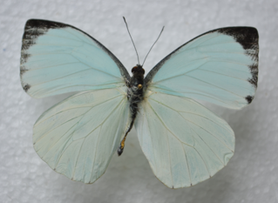
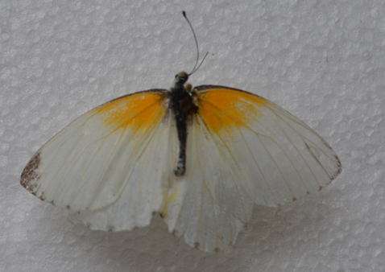
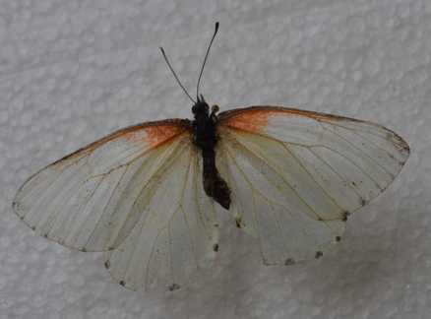

Locality: KBR
Woreda: Gawata
Kebele: Dema
Altitude: 1757m
Habitat: Buffer
Sc. Name: Nepheronia thalassina
.

Locality: KBR
Woreda: Gimbo
Kebele: Tula
Altitude: 1703m
Habitat: Agriculture
Sc. Name: Nepheronia argia

Locality: KBR
Woreda: Gawata
Kebele: Dema
Altitude: 1770m
Habitat: Buffer
Sc. Name: Mylothris agathina

Hymenoptera

Apidae Family
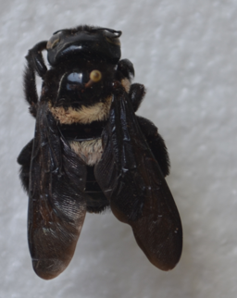
Locality: KBR
Woreda: Gimbo
Kebele: Tula
Altitude: 1833m
Habitat: Agriculture
Sc. Name: Xylocopa spp.

Key morphological features
- Medium sized bees, 16 – 25 mm in length
- Their wing are dark brown with vibrant green or blue iridescent reflections
Key Habitat Characteristics
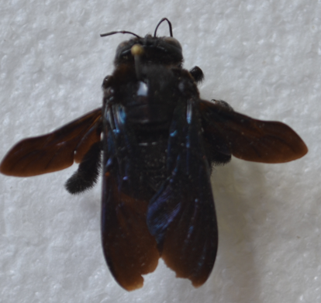
Locality: KBR
Woreda: Gawata
Kebele: Emicho
Altitude: 2129m
Habitat: Core
Sc. Name: Xylocopa combusta

Key morphological features
- Black body with black hair on the head and the thorax
- Bristles on the pygidial area are reddish
Key Habitat Characteristics

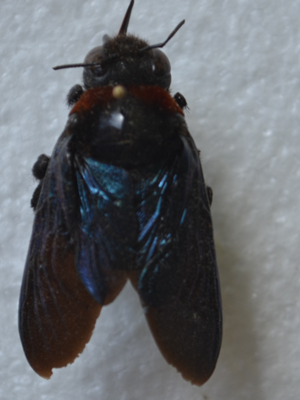
Locality: KBR
Woreda: Gawata
Kebele: Dema
Altitude: 1756m
Habitat: Buffer
Sc. Name: Xylocopa flavorufa

Key morphological features
- Large size, with females reaching lengths of up to 2.5 cm (1 in), mostly black, with reddish yellow color on the thorax
- Males possess hollows on their hind legs, while females have pollen baskets
Key Habitat Characteristics
Locality: KBR
Woreda: Gawata
Kebele: Emicho
Altitude: 1962m
Habitat: Core
Sc. Name: Xylocopa inconstans

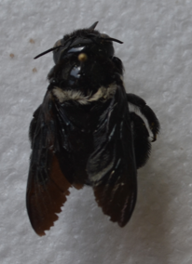

Key morphological features
- Total body length of 26 mm and forewing length 21–23 mm
- The back side of the mesosoma and the first tergite show a white pubescence
Key Habitat Characteristics

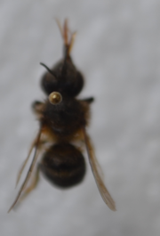
Locality: KBR
Woreda: Gawata
Kebele: Emicho
Altitude: 1962m
Habitat: Core
Sc. Name: Apis mellifera

Key morphological features
- Long antennal flagellum; pale yellow stripes adjacent to the eye
- Marginal cell of forewing long, about four times as long as distance between marginal cell and distal end of forewing.
Key Habitat Characteristics
Diptera
Syrphidae Family

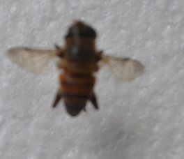
Locality: KBR
Woreda: Gawata
Kebele: Dema
Altitude: 1743m
Habitat: Buffer
Sc. Name: Phytomia spp.

Key morphological features
- They are typically characterized by their striking color patterns and long, extendable proboscis
Key Habitat Characteristics

